Artreach India
Newsletter Vol. 1, Qtr. 2, 2015
Here is a glimpse of our activities in 2015!
Volunteer Residencies
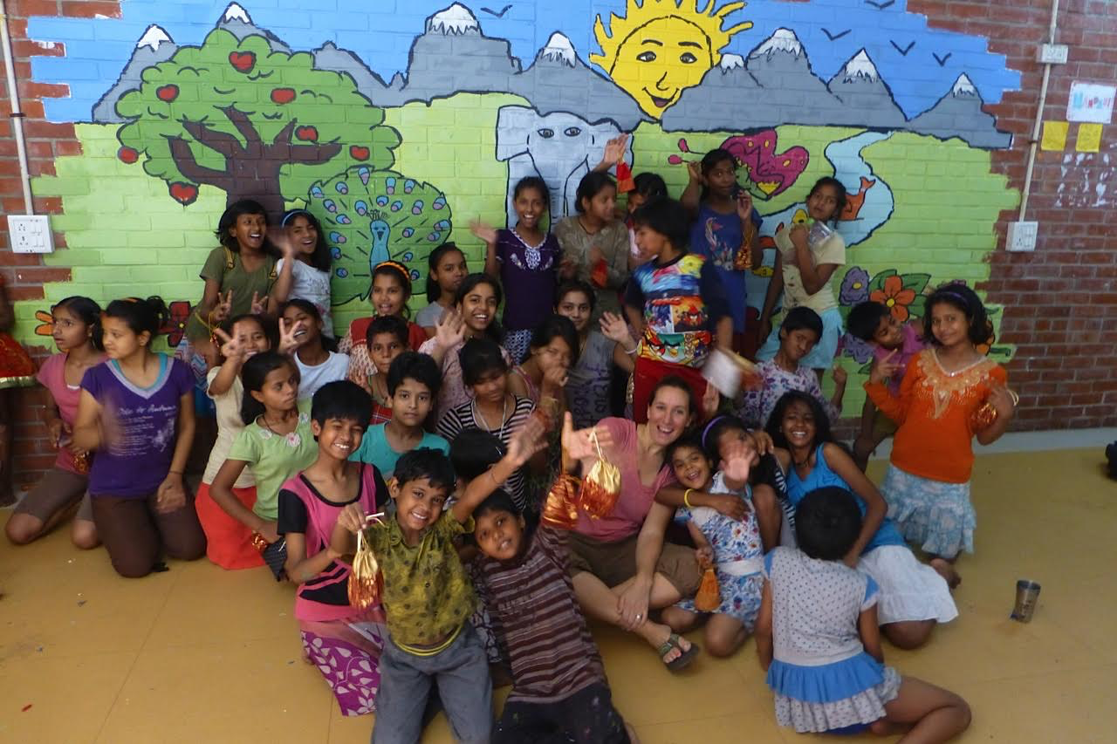
A big THANK YOU to our volunteers who gave their time, energy, skill and love to Artreach projects in 2015

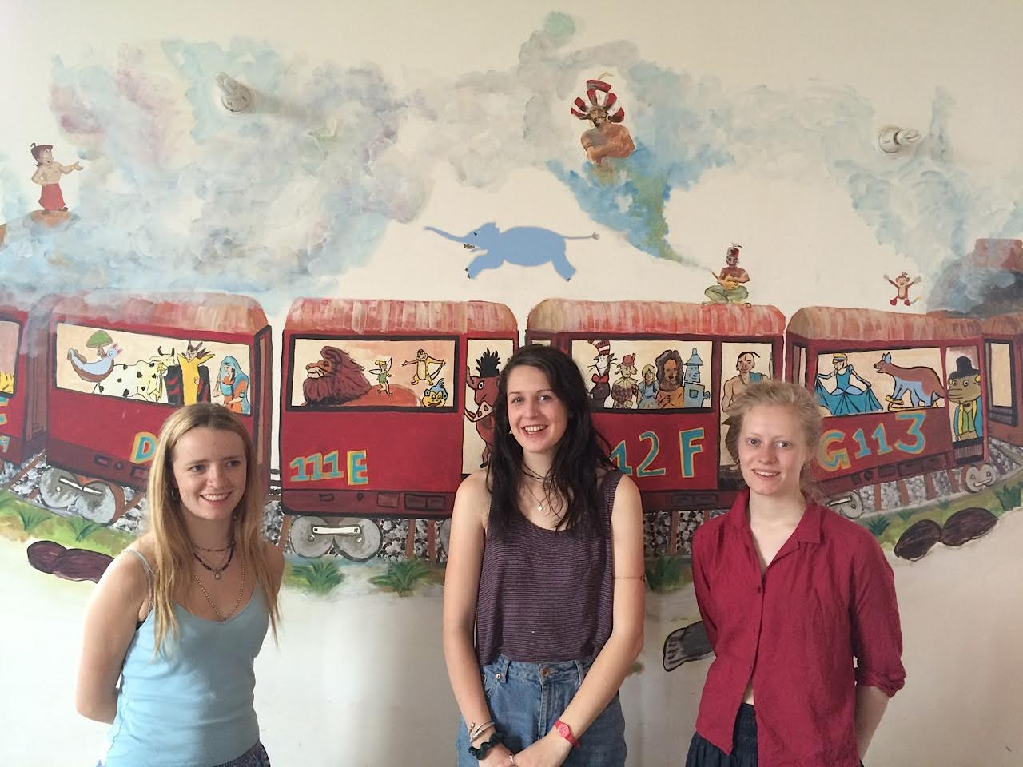
Cassie Pupovac, an American artist teaching at the American Embassy School in Delhi created a happy landscape with the girls of Salaam Baalak Trust’s Udaan Home after several months of workshops.

In April three young British artists, Ibby Dalrymple, Beatrice Hasell-McCosh and Aoife Kenny spent a long weekend with a group of older children painting the walls of the Gairatpur Baas Panchayat School library in Tikli Bottom.
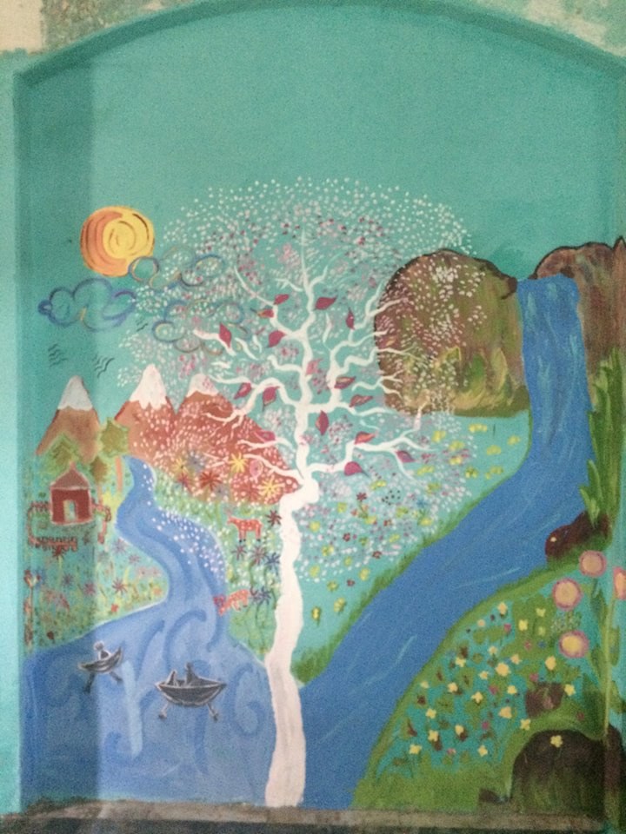

In March Saba Hasan spent a fun-filled week painting with the girls of Kilkari home.
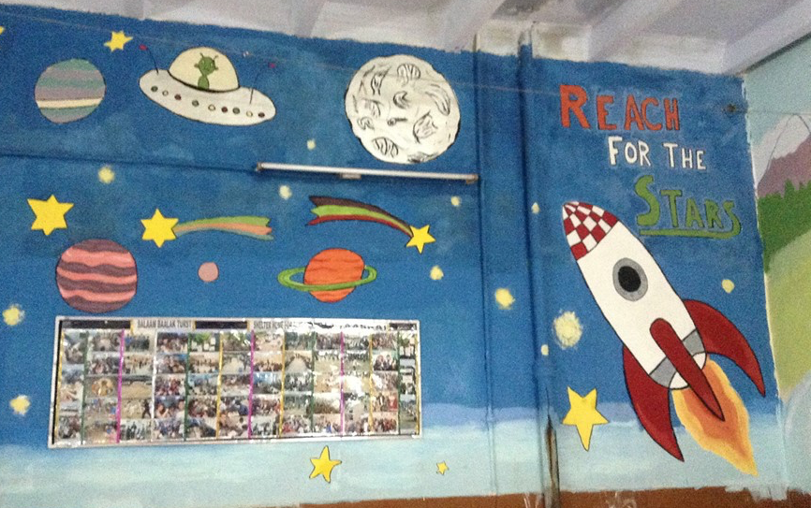
“Your presence at Kilkari gave our children a sea of opportunities to learn new things and look at things differently. You have inspired them to do things in their own ways. Nothing could be better than this…” Rashmi, Home Leader.

In May and June Theo Neilson spent three weeks at Salaam Baalak Trust’s home ‘Aasra’. Together, he and the boys painted ‘Reach for the Stars’ in the foyer.
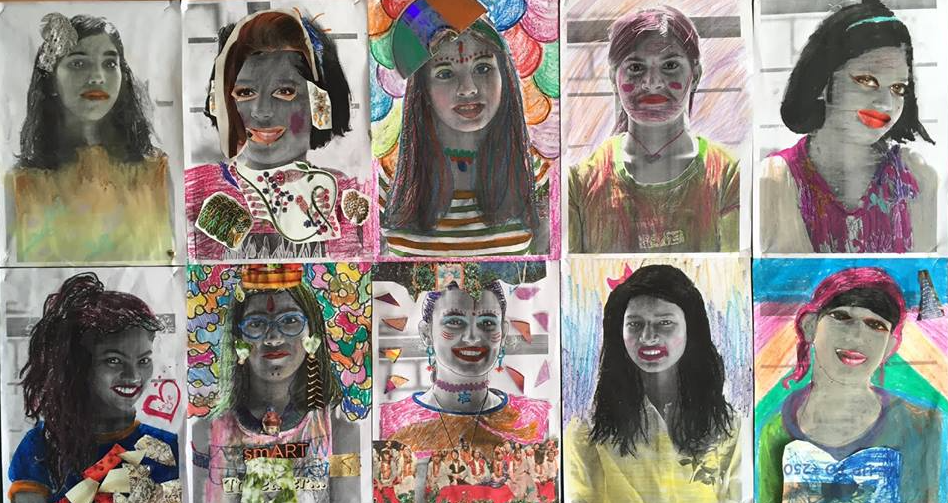

In September and October Charlotte J. Ward painted a mural and conducted a collage workshop with the girls of Udayan Care. Together they explored the question, ‘Who Am I?’

See http://www.artreachindia.com/volunteer-residencies.html to know more.

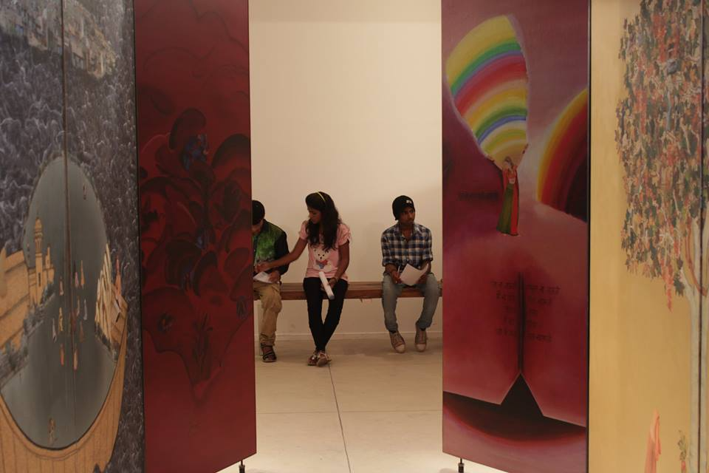
Teaching Fellowship

In 2015 Artreach India instituted a 10 month long Teaching Fellowship. Akin to an intensive Foundation programme, the Teaching Fellowship introduces young adults to materials, techniques, history and institutions.

It also encourages them to use art as a tool for the critical exploration of the world, to cultivate their imaginative, creative and reflective skills, and to find an individual expressive voice.

Our first Teaching Fellowship is in partnership with Aman Biradari – Rainbow Homes and our Teaching Fellow Anni K. Sharan was selected through an Open Call and trial workshop.

A distinguished panel - Atul Bhalla, Bindu Prasad Gauri Gill, Kristine Michael and Susanta Mandal – is guiding us through the process.
To read more about the fellowship visit http://www.artreachindia.com/teaching-fellowship.html and our Facebook page https://www.facebook.com/artreachindia/
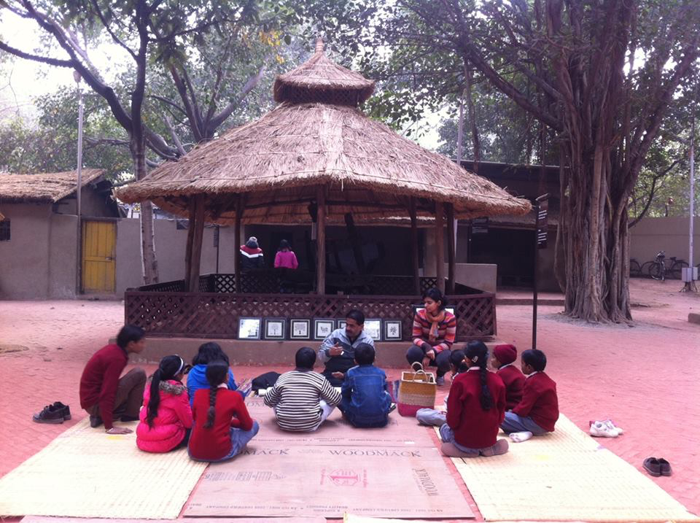
Khel Mel
Bringing Children Together

Khel Mel workshops bring together children from diverse socio-economic backgrounds to interact in an environment of creativity, learning and fun. The workshops are led by a master craftsperson and facilitated by an artist.

Our first Khel Mel Facilitator Grant was awarded to artist Sunandita Mehrotra for Khel Mel 2015-16 programme.

This year’s programme is in collaboration with the Crafts Museum and all workshops – Madhubani, Sanjhi and Katputli so far – are held in the museum. Our partner NGOs are Nirmal Primary School and Karm Marg.

To know more about Khel Mel visit http://www.artreachindia.com/khel-mel.html, our blog and archive http://khelmel.weebly.com/ and our Facebook page https://www.facebook.com/khelmelworkshops

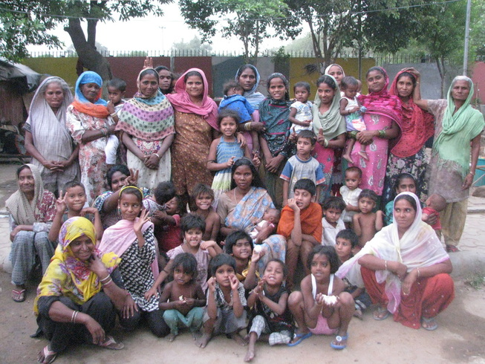
Community Arts Grant

In Aprils 2015, Artreach India awarded Revue – Sreejata Roy and Mrityunjay Chatterjee – a grant to work with the women and children at the Urdu Park women’s shelter in Jama Masjid, Old Delhi.
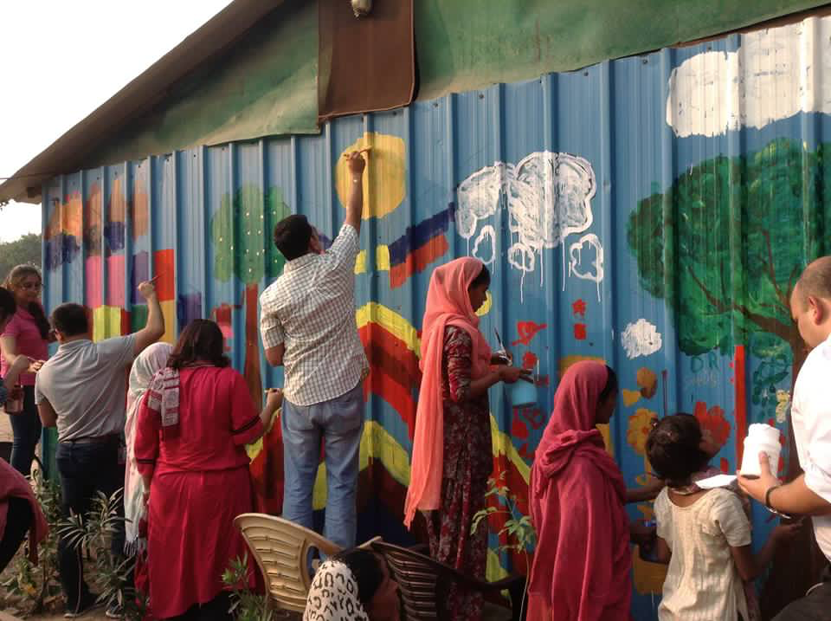
Sreejata visits the homeless shelter twice a week and interacts with about 16 women there, using art as a medium to help them negotiate their lives in this very public space and as a tool for nurturing community.

In November, members of the Gates Foundation visited Urdu Park and with the women and children painted a mural on the outside of the shelter.

To read more about this wonderful project visit http://www.artreachindia.com/community-arts.html and the project blog https://axialmargins.wordpress.com/

Our work needs your support.

Volunteer time – Donate materials – Support us

To see how you can get involved visit http://www.artreachindia.com/support-us.html and email our Director Deeksha Nath at director.artreach@gmail.com

We’re currently recruiting - if you’re a dynamic self-starter with a background in an NGO or arts organisation and would like to explore the possibility of working for Artreach, please get in touch!

Artreach India is a registered Charitable Trust

