Newsletter Vol. 2, Qtr. 1, 2016

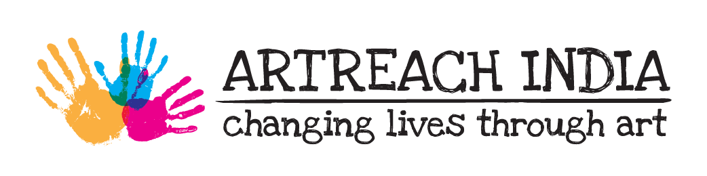

**Teaching Fellowship**

We successfully completed our first Teaching Fellowship with the 20 young artists from Aman-Biradari Rainbow Homes.

Our Teaching Fellow AnniKumari led the participants through 12 workshops, 3 field trips, an intensive and an Open Day.

The Intensive, mentored by artist SusantaMandal, resulted in a mural painted by the participants at UmmeedGhar, also the site of the Open Day exhibition, where each artist displayed 5 curated works. A catalogue and video of interviews with the young artists accompanied the exhibition.

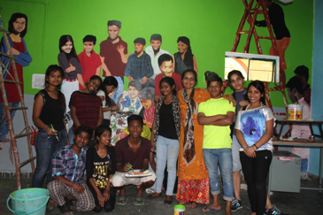

To see more about the programme and watch a short video visit <http://www.artreachindia.com/teaching-fellowship.html>

Artreach India’s Second Teaching Fellowship has begun!

In partnership with Udayan Care and supported by the Kiran Nadar Museum of Art, 20 young artists will be taught by artist Vandana Kothari.

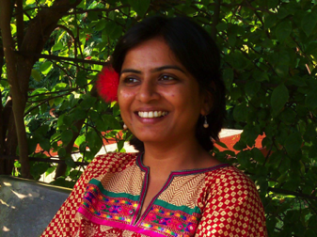

Vandana trained at Santiniketan and has over 3 years experience teaching art at various institutes including the IIT. She is current Assistant Professor of Art at the School of Planning and Architecture.

A distinguished panel - Atul Bhalla, Susanta Mandal, Kristine Michael, Anni Kumari, Kiran Modi, Akansha Rastogi and Roobina Karode – is guiding us through the process.

A BIG Thank you to KNMA who are sponsoring the fellowship.

Read about our programmes from January-July 2016!

**Volunteer Residencies**

**A big THANK YOU to our volunteers who gave their time, energy,**

**skill and love to Artreach projects in 2016**

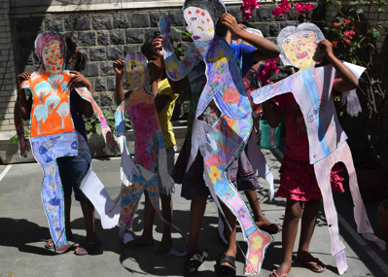

Over two weekends in March, artist Nilanjana Nandy spent 5

days with the girls of Tara. Together they made self portraits,

life size puppets and a large painting for their new home.

In April artists and sisters Niqita and Komal Gupta flew down

from Mumbai to spend a long weekend at the Udayan Care

Ghar in Ghaziabad. The weekend reulted in a beautiful

seascape mural.

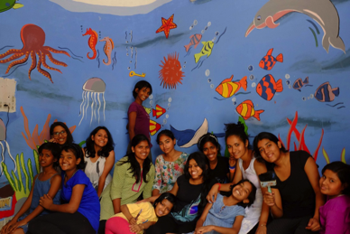

See<http://www.artreachindia.com/volunteer-residencies.html> to know more.

**Community Arts Grant**

Since April 2015, Revue: Sreejata Roy and Mrityunjay Chatterjee, have been working with the homeless women at the SPYM shelter in Urdu Park, Jama Masjid.

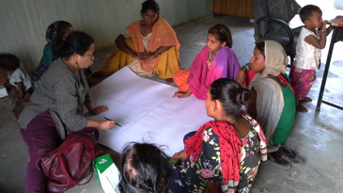

In March an Open Day was held at Urdu Park where audiences got a chance to interact with the women and children. The art works were on sale. Proceeds were used to create a medical bank for the women.

The project now enters its second year with support from Artreach India for 2016-17.

In April Artreach India gave its second community arts grant to artist Avinash Karn for his project Udbhav in village Chandidih in Jharkhand.

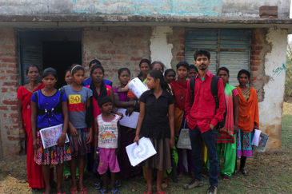

From April 2016-March 2017, Avinash will conduct workshops with the residents of the village and together they will paint 8 murals on the buildings.

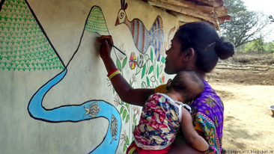

Read more about our projects at <http://www.artreachindia.com/community-arts.html> and the project blogs<https://axialmargins.wordpress.com/> and http://udbhavproject.blogspot.in/

Artreach India Art Room

In July Artreach India held its first workshop as part of the Art Room, a space designed for the alumni of our Teaching Fellowship and Residency programmes offering them access to materials, the opportunity to learn from different artists and to further explore and expand their artistic skills.It is a space for ongoing engagement, the exchange of ideas and artistic encouragement and growth.

Mumbai artist Trishna Gupta held a charcoal workshop for the Aman Biradari-Rainbow Homes Teaching Fellowship alumni at Khushi Ghar.

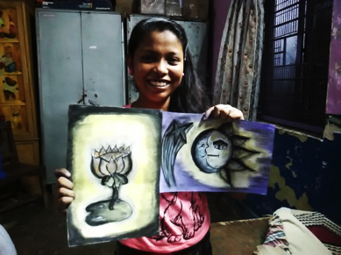

**Khel Mel**

**Bringing Children Together**

Khel Mel workshops bring together children from diverse socio-economic backgrounds to interact in an environment of creativity, learning and fun. The workshops are led by a master craftsperson and facilitated by an artist.

In May we completed 6 Khel Mel workshops that ran from Nov. 2015- May 2016 at the Crafts Museum.

With artist-facilitator Sunandita Mehrotra, over 40 children learnt 6 Indian crafts:

Madhubani painting , Sanjhi paper cutting, Katputli puppet making, Patachitra painting, Bhil painting and terracotta sculptures.

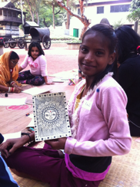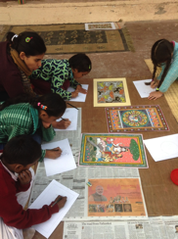

We partnered with 2 organizations: Karm Marg and Nirmal Primary School for the series.

To know more about Khel Mel visit <http://www.artreachindia.com/khel-mel.html>, our blog and archive <http://khelmel.weebly.com/> and our Facebook page <https://www.facebook.com/khelmelworkshops>

Our work needs your support.

Volunteer time - Donate materials - Support us

To see how you can get involved visit <http://www.artreachindia.com/support-us.html> and email our Director Deeksha Nath at [director.artreach@gmail.com](mailto:director.artreach@gmail.com)

Artreach India is a registered Charitable Trust

Mailing Address

N 150A Panchsheel Park, New Delhi 110017

Registered Address

3 Local Shopping Centre, Uday Park, New Delhi 110049

[www.artreachindia.org](http://www.artreachindia.org)

Visit our Facebook pages [Artreach](https://www.facebook.com/artreachindia" \t "_blank) and [Khel Mel Workshops](https://www.facebook.com/khelmelworkshops" \t "_blank)

Also,

As part of Publica, the public art festival held in New Delhi from Jan-March 2016, five boys from the first Teaching Fellowship visited the studio of artist Arun Kumar H.G. and observed and assisted in the creation of the art work that was on diplay at the India Habitat Centre.

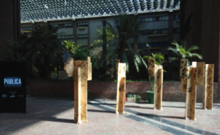

In July, Artreach India facilitated the visit of children from Jamghat, Salaam Baalak Trust, Karm Marg and Udayan Care to view the Himmat Shah exhibition at the Kiran Nadar Museum of Art. About 150 children visited the museum in a span of 2 weeks.

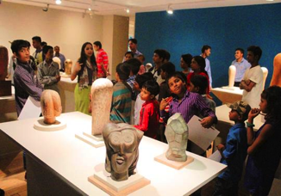

A Big Thank You

To all the organizations and individuals that have supported us in 2016

*For our fabulous logo*

Tim Kerr of Brainstorm Design



*For the Second Teaching Fellowship*

The Kiran Nadar Museum of Art

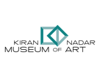

*For the First Teaching Fellowship*

Mohit Gupta and Alissa Sheth

Nilima Sheikh

Tasneem Zakaria Mehta

Jyotsna Singh

Samini Philip

Madhur Sen

